Software Requirements and Design (SRD)
Project Title: PixelPals
Module: CS2TP Team Project
Date: 19.10.2025
Version: Draft 1.0

Table of Contents
Contents
1. Team Information 2
1.1 Team Roles and Belbin Responsibilities 2
1.2 Team Logo and Identity 2
2. Project Description 2
2.1 Project Overview 2
2.2 Vision and Objectives 3
2.3 Target Audience 3
2.4 Technologies and Tools 3
3. Functional Requirements 3
3.1 Introduction 3
3.2 Requirement List (FR1–FR5) 3
4. Non-Functional Requirements 3
4.1 Performance 3
4.2 Security 4
4.3 Usability and Accessibility 4
4.4 Maintainability 4
5. Use Cases and Design 4
5.1 Use Case Diagram (optional) 4
5.2 Use Cases – Products 4
5.3 Use Cases – Login & Basket 4
5.4 Interface Wireframes 4
5.5 Database Design (ERD) 4
5.6 Flow Diagrams (Admin/User Journey) 4
5.7 Site Map 4
6. Project Management 5
6.1 Development Methodology 5
6.2 Project Planning Tools (Trello) 5
6.3 Communication and Collaboration 5
6.4 Version Control and File Management (GitHub) 5
6.5 Design and Technical Overview 5
6.6 Team Section Responsibilities 5
7. Conclusion 6
Appendices 6
Appendix A – Entity Relationship Diagram 6
Appendix B – Admin Flow Diagram 6
Appendix C – Wireframes and Brand Design 6
Appendix D – User Journey Diagram 6
Appendix E – Product Grid (optional) 6
Appendix F – Site Map 6

(Right-click → Update Field → Update Entire Table once complete)

1. Team Information

1.1 Team Roles and Belbin Responsibilities
List each team member, their role, and main responsibility.

1.2 Team Logo and Identity

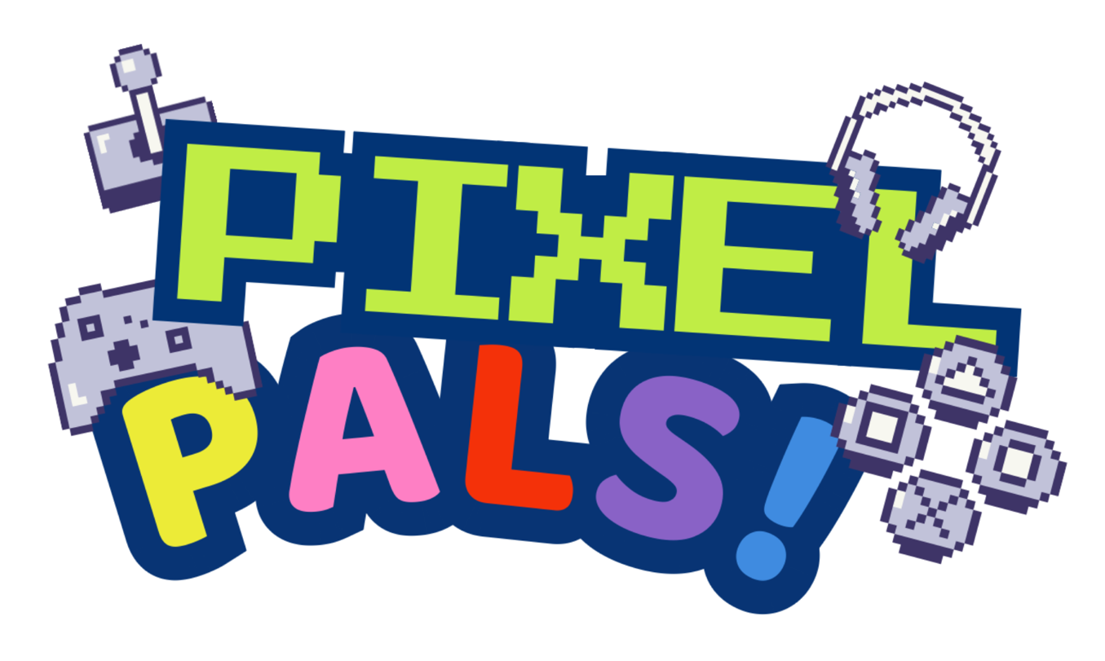
PixelPals is an exciting, playful, and tech-driven e-commerce brand which create fun and ergonomic gaming accessories for kids. The logo reflects the brand’s identity through a retro, pixel art style, creating a nostalgic connection for parents while also engaging younger, modern audiences through its vibrant and lively colours.

The primary colours, Dark Blue (#023475) and Lime Green (#C0ED45) create a bold contrast between energy and depth, making the design eye-catching but also enhances readability. Secondary colours, including Yellow (#ECEB38), Pink (#FE7FC4), Red (#F5300A), Purple (#8962C6), and Blue (#3F8BE0), enhance the playful and dynamic feel of the brand and highlights creativity and variety.

The typography combines the nostalgic ‘Press Start 2P’ arcade-style font, and the friendly, bubble-like ‘Baloo’ font to create a balanced blend of digitality and child-like imagination. Together, these design choices for PixelPals showcase its brand identity as fun, youthful, and tech-savvy, whilst perfectly aligning with the target audience.

2. Project Description

2.1 Project Overview
Briefly describe what your project is about, its purpose, and context.

2.2 Vision and Objectives
Write a short statement outlining your overall goal and measurable objectives.

2.3 Target Audience
Describe who your product is for (e.g. children, parents, accessible users).

2.4 Technologies and Tools
List programming languages, frameworks, and tools used.

3. Functional Requirements

3.1 Introduction
Functional Requirements is based on what the system should do, This can done by the usage of features, specific actions, and behaviours so that it helps the user throughout the website. For the PixelPals Project, Function Requirements will make sure that system functionally will allow the users to register, sign in, placing orders and adding Parent control. Furthermore, Function Requirements will support both users and admins by providing features to manage and interact with the ecommerce website with ease .

3.2 Requirement List (FR1–FR5)
List and describe each functional requirement (FR1, FR2, etc.).
1. The System will allow the users login and register
2. The system will allow the users to add items into their baskets + place orders
3. The System will allow admins to manage and view products
4. The System will allow the users to add a parent to allow the parents monitor the users account
5. The System will allow the users to place and order and review

4. Non-Functional Requirements

4.1 Performance
State any speed, responsiveness, or load time requirements.

4.2 Security
Explain how you’ll protect user data and ensure secure access.

4.3 Usability and Accessibility
The PixelPals website is designed to be engaging, and simple to use for both children and parents. It follows key UX principles such as consistency, simplicity, intuitive navigation, visual hierarchy, and accessibility. The layout is consistent across all sections, featuring a clear header, navigation bar, footer, and identifiable Wishlist and basket icons. Visual hierarchy is establishing using large, bold headings, a vibrant hero banner at the top, and an organised product grid to help users quickly find what they’re looking for. Accessibility is also considered in the design, to ensure inclusivity for all users, with large, readable fonts, high contrast colour palette, and consistent use of typography and icons to support users with cognitive or visual difficulties by reducing the need to relearn navigation. Language and accessibility icons are also included, allowing users to adjust text size or switch to their preferred language. These design choice accommodate for a wide and diverse audience.

4.4 Maintainability
Discuss coding practices, documentation, and scalability.

5. Use Cases and Design

5.1 Use Case Diagram (optional)
Insert your use case diagram or describe it.

5.2 Use Cases – Products
Describe product browsing, searching, and filtering features.

5.3 Use Cases – Login & Basket
Describe login, account, and basket management features.

5.4 Interface Wireframes

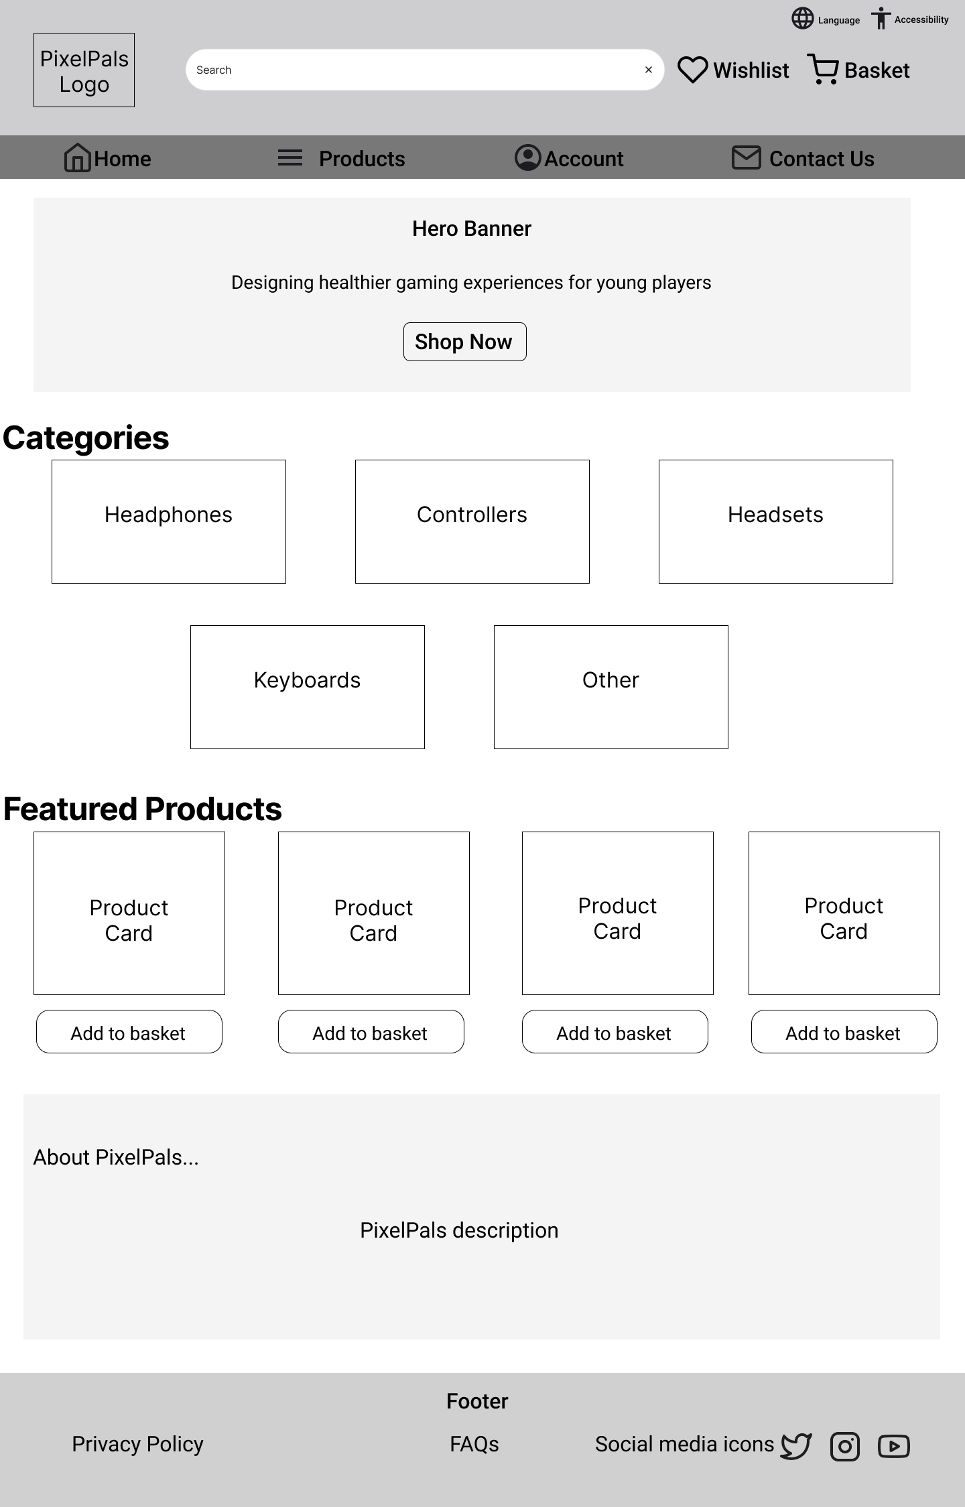
This is the low fidelity homepage wireframe, made using Figma, which mainly focuses on the layout and structure. As mentioned in 4.3, it shows the placement of key elements such as the navigation bar, the hero banner, product grid, and header. Each section is clearly annotated to briefly explain its purpose.

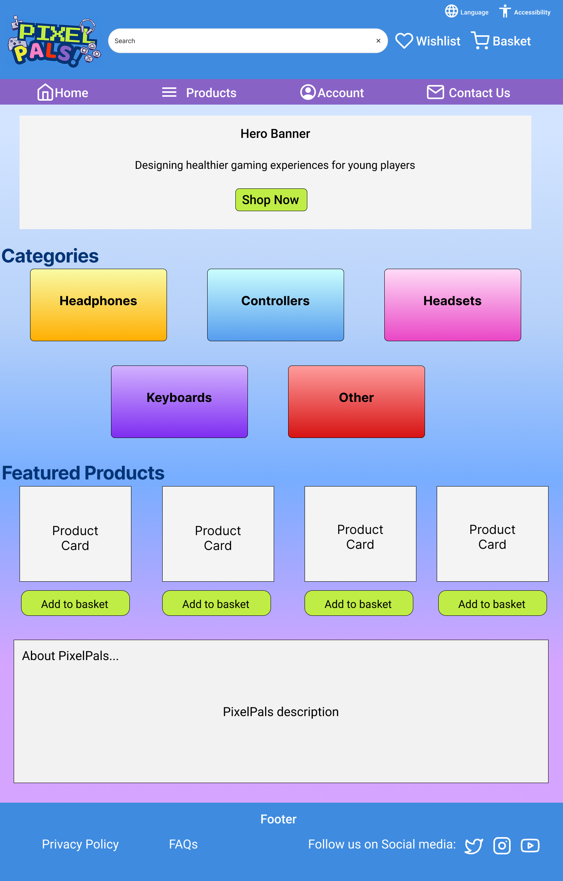

This is the high-fidelity wireframe, also created using Figma. It represents the final visual design of the homepage, showing the vibrant colour palette which reflects PixelPals brand identity.

5.5 Database Design (ERD)
Insert your ERD diagram and explain relationships between tables.

5.6 Flow Diagrams (Admin/User Journey)
Insert admin or user journey flow diagram.

5.7 Site Map
This site map is an illustration of the list of links on the PixelPals website, showing how users can navigate between pages such as Home, Products, Basket, and Account. It visually maps the structure and hierarchy of the website’s main contents, ensuring clear and user-friendly movement across the website.

6. Project Management

6.1 Development Methodology
Explain the methodology used (Agile/Scrum) and why it was chosen.

6.2 Project Planning Tools (Trello)
Include link/screenshot of your Trello board and describe how it was used.

6.3 Communication and Collaboration
Describe how your team communicated (e.g., Discord, in-person meetings).

6.4 Version Control and File Management (GitHub)
Include your GitHub repository link and discuss how you managed versions.

6.5 Design and Technical Overview
The design of PixelPals focused on creating a fun, child-centred, and visually appealing shopping experience that is also suitable for parents. The interface includes soft, saturated colours that are bright and engaging without being too washed out: Bright Blue (#3F8BE0) is used in the header and footer to create consistency and complement the logo, while the navigation bar uses Purple (#8962C6) to add visual balance next to the blue header. Text and icons are White (#FFFFFF) for clarity and readability.
Interactive elements, such as the buttons “Add to Basket” and the CTA button “Shop Now” use Lime Green (#C0ED45), making them eye-catching, encouraging users to interact with them. The category tiles are coloured to coordinate with the characters in the PixelPals logo (“PALS!”), with a subtle gradient to make them feel more dynamic and playful rather than flat and solid. The consistent use of these secondary colours reinforces the brand’s identity further. The gradient background maintains a good colour contrast between the text and background, ensuring it is accessible for all users, including users with visual impairments.
Figma was used to create the websites layout and wireframes, and Canva was used to create the logo and visuals.

6.6 Team Section Responsibilities
The following table details which team member is responsible for each SRD section.
Section No. | Section Title | Assigned Member(s)

7. Conclusion

Appendices

Appendix A – Entity Relationship Diagram
Insert ERD diagram here.

Appendix B – Admin Flow Diagram
Insert admin flow diagram here.

Appendix C – Wireframes and Brand Design
1.2 Logo:
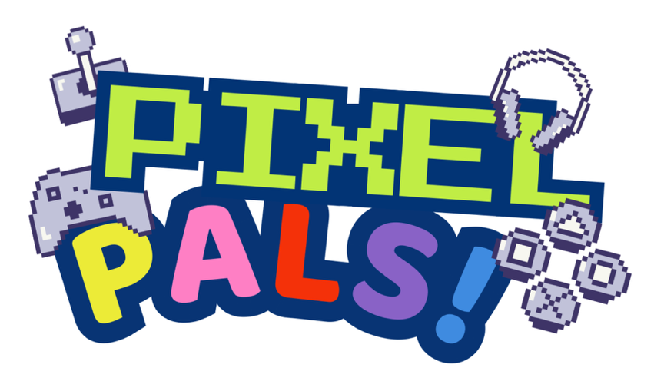

5.4 Low-fidelity Homepage wireframe:

5.4 High fidelity homepage wireframe:


Brand Notes:
Name: PixelPals
Audience: Parents and Young Children interested in Gaming and Computers
Identity: Fun, playful, modern, digital, kid-friendly

Colour Palette
Primary Colour:
- Bright Blue: #3F8BE0 – clean, easy on eyes

Secondary Colours:
- Yellow: #ECEB38 - fun
- Pink: #FE7FC4 - playful
- Red: #F5300A - energetic
- Purple: #8962C6 – friendly

Accent Colour:
- Lime Green: #C0ED45 – vibrant and eye-catching to buttons.
- Dark Navy: #023475 – high contrast for readability

Background Colour:
A soft gradient flowing from:
  - Powder Blue: #DE4FFF
  - Blue: #77ADFF
  - Lilac: #D5A4FF
This creates a dynamic background that makes the website aesthetically appealing and engaging.

Typography:
- Headings: ADLaM Display— round, modern, playful
  - Font size: 22px
- Body Text: Arial Regular — simple and very readable
  - Font size: 16px

Appendix D – User Journey Diagram
Insert user journey diagram here.

Appendix E – Product Grid (optional)
Insert product grid design or screenshots here.

Appendix F – Site Map
This diagram outlines the main structure of the PixelPals website, illustrating the hierarchy and navigation flow between main pages of the website.

